ADDING LOGGER
- In Api module, add nuget package called Serilog.AspNetCore
- Add Serilog into our project have 2 ways
  - Option A: Add serilog in program.cs (can try first)
In Program.cs
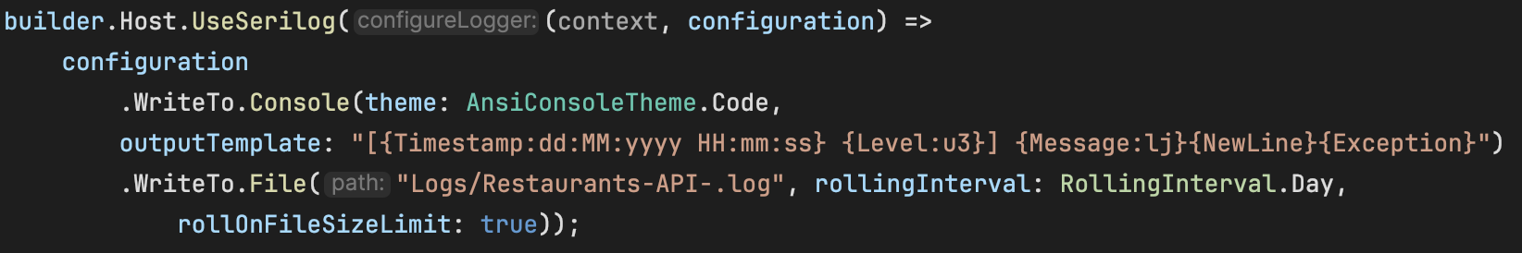
  - Option 2 (Recommended): Add in the appsettings.Development.json and Program.cs
In Program.cs
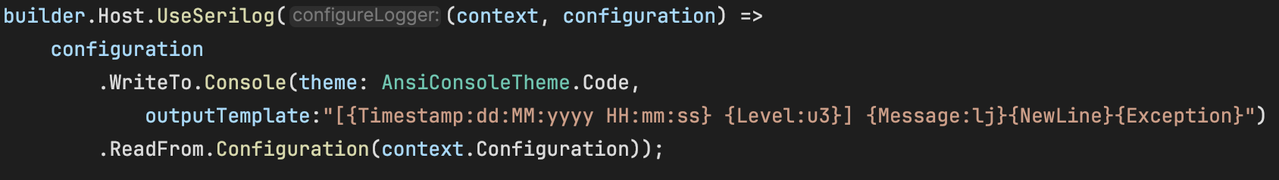
In appsettings.Development.json
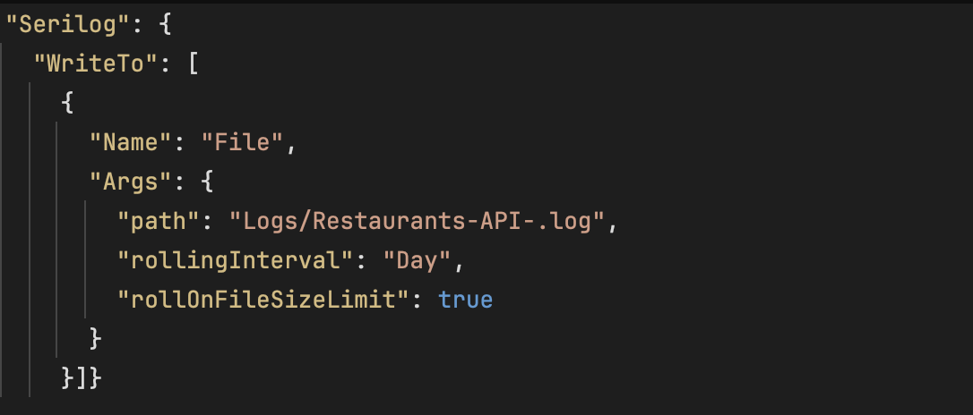
Actually, we need to add the console here also but I decide to put in program.cs because of the color configuration setup (AnsiConsoleTheme) in console are not working.
Result in console:
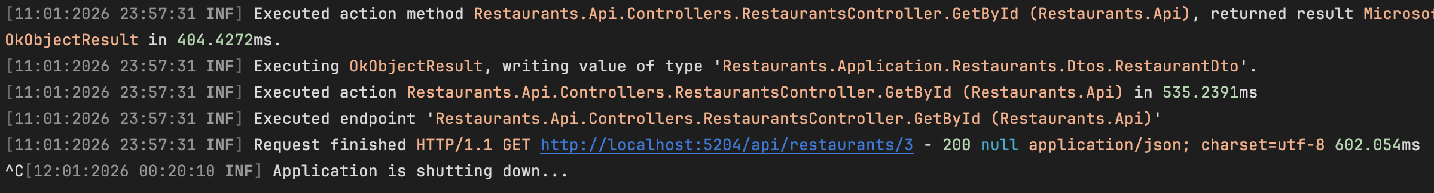
Result in log file:
